**Overall View**

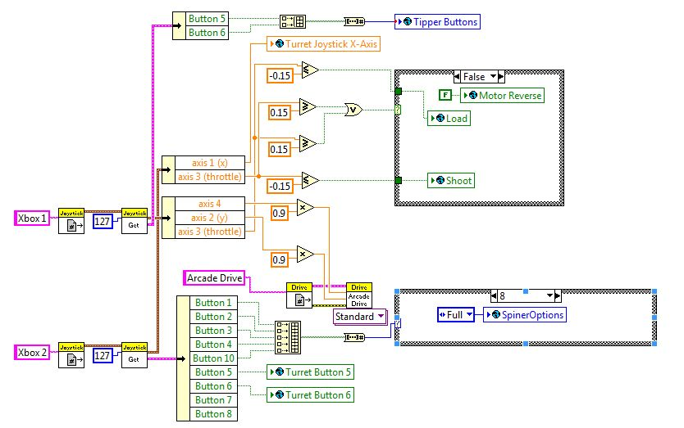

1. **Joystick Input:** opened two references to the two joysticks and got the button input Booleans from Joystick Get.vi cluster (see comments within the VI for button/axis explanations).

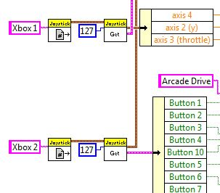

1. **Tipper Buttons:** two of the joystick buttons assigned to the robot bridge tipper (up/down)
2. **First Case Structure:** determines whether the motor is reversed, and decides when the robot will perform the Load or Shoot actions.

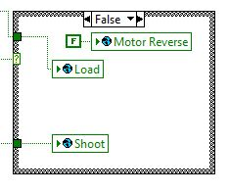

1. **Arcade Drive**: opens up the arcade drive reference and moves the robot drive based on joystick inputs from the user.

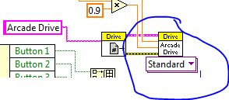

1. **Second Case Structure**: gets joystick button inputs and determines the speed at which the motor will run (to be used in SetVelocity.vi)

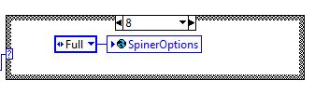

1. **Turret Buttons**: gets inputs from the joysticks and determines left/right movement of the robot turret (to be used in Periodic Tasks.vi)

